Michael Collins Division 1 Denver Colorado
Organized 1986
Division Newsletter Nov/Dec 2023
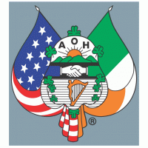

Officers:
Chaplain - Deacon Jim Blume
President -Tim Henning
Vice President -John Aylward
Recording Secretary -Neil Quinlivan
Financial Secretary- Ted Rhoades
Treasurer -Michael Collins
Standing Committee Chairman- Bill Fetherston
Marshall -Sean Hudson
Sentinel -Jim O’Shea III

Committee Chairmen:
Committee on the Sick - Bill Beach
FFIA - Ed O’Shaunessy
Pro Life- Deacon Jim Blume, Ted Rhoades
Immigration- Ted Rhoades
Rituals and Degrees -John Aylward
Parade- Peter Kirwin, Mike Regan, Michael Collins
Hibernian Hunger -Tim Henning
Veterans Affairs -Brendan O’Neill, Bill Beach
Denver Gaels/GAA Liaison- Kevin Zahler
Entertainment Committee- Jim O’Shea
Social Media -Kevin Jones
Web Manager -Sean Hudson
Immediate Past President- Kevin Jones

Michael Collins Division Past Presidents:
Aidan McGuire
Tom Burke
Phil Lanphier
Jim Sullivan
Tom Maloney
Tom Myers
John Murrow
Brian O'Connell
Tom Morrissey
Dave Beauman
Kevin Jones
Jeff Rodenberg
Bill Fetherston
Peter Kirwin
Mark Stutz
Pat Tierney
John Morrisroe

SACRED HEART FOOD DRIVE
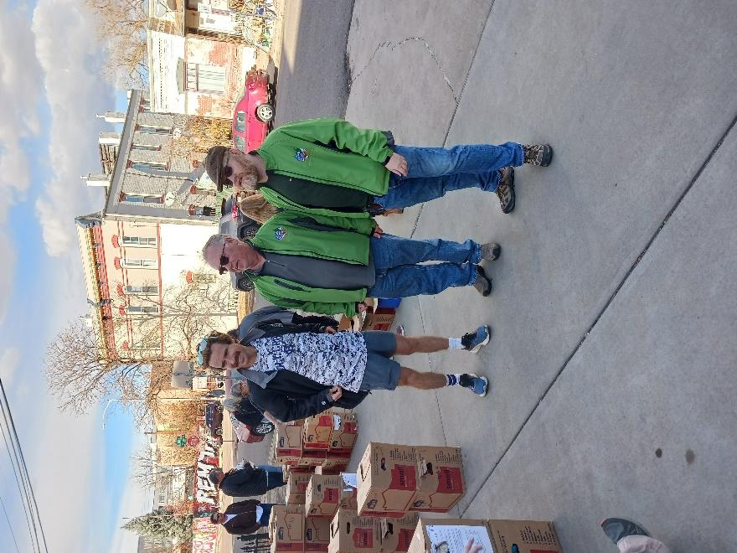
Liam Driscoll - Fr. Carrigan Division along with Tim and Kevin ponder the question, “If we pray hard enough will these boxes move themselves”.

GIVING COMFORT THROUGH CHRISTIAN CHARITY

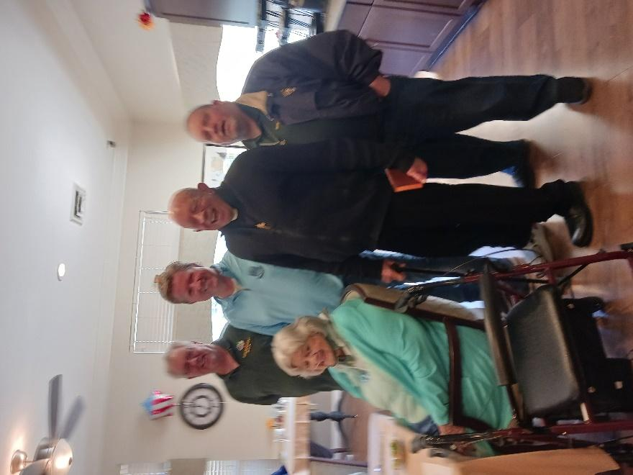
John M., Bill B., Deacon Jim and I had a wonderful visit with Louise Donovan, the founder of the LAOH in Colorado. Louise fell recently and broke bones in her neck and back but is on the road to recovery. What an amazing lady, she was in great spirits.

COLORADO STATE CONVENTION 2023
The evening of Saturday, October 28th, 2023, was a historic moment; the Colorado Hibernians had their first State Convention in many years.
On that snowy evening we traveled to the Willow Creek 3 Clubhouse in Centennial, Colorado. There was a meet-and-greet, followed by a business meeting where our state officers were elected.
We then went to a Mass, where the Colorado Hibernians were recognized, at St. Thomas More Catholic Church.

After the Mass we returned to the club house to swear in our new state officers:

President – Patrick McGuire
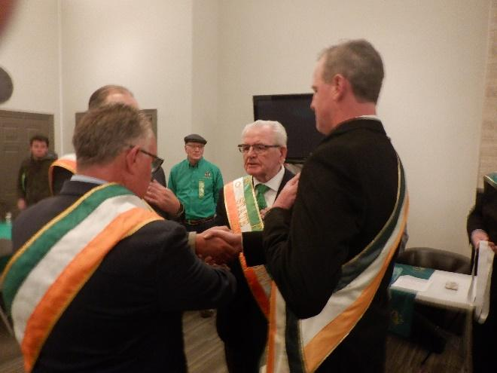
Vice President – Tim Henning
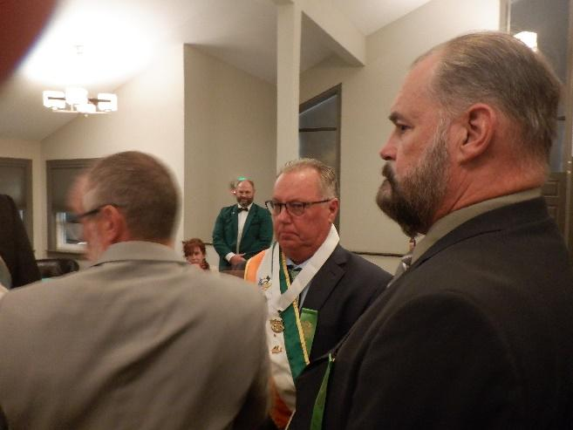

Treasurer – Jeff Rodenberg
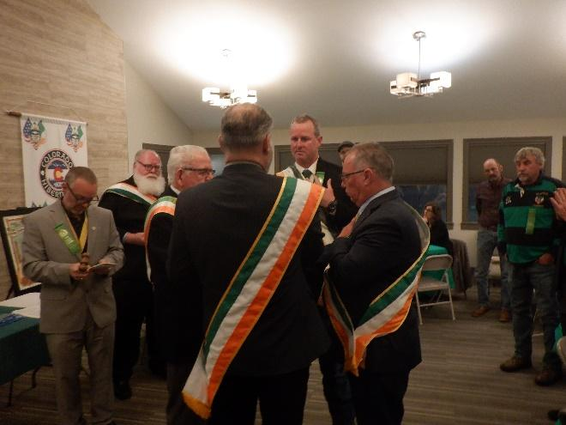
Recording Secretary – John Alyward
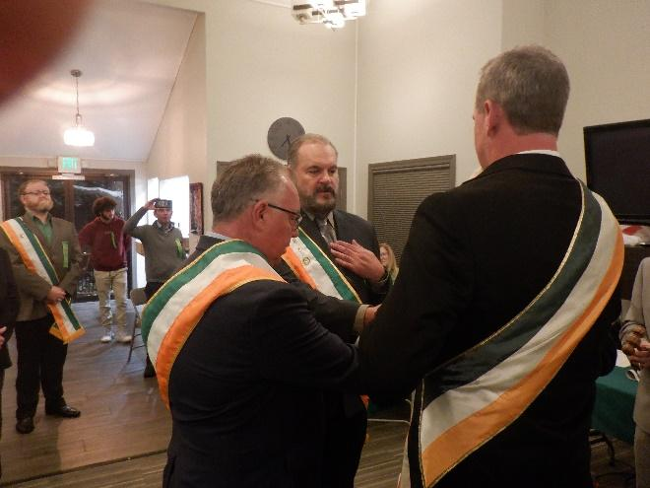

Past President – Bill Fetherston
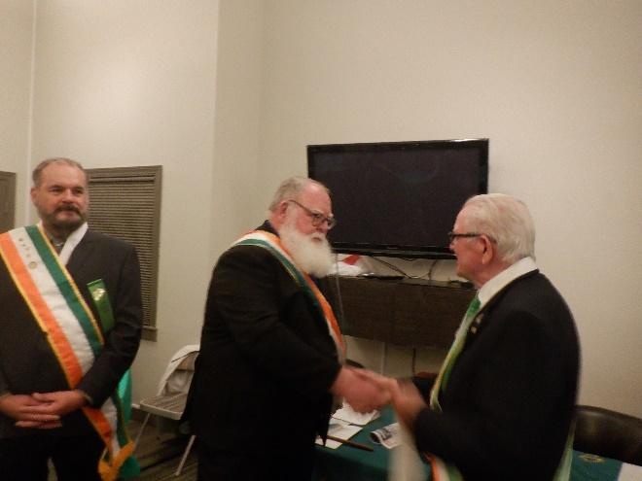

Patrick McGuire being sworn in as the new State President for Colorado by our National Director, Bob Mehrens
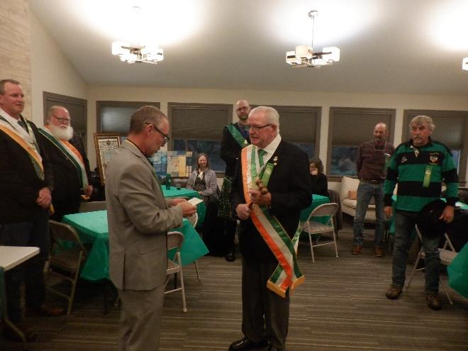

Patricik McGuire presents Bob Mehrans with a commemorative plaque from our State Chapter
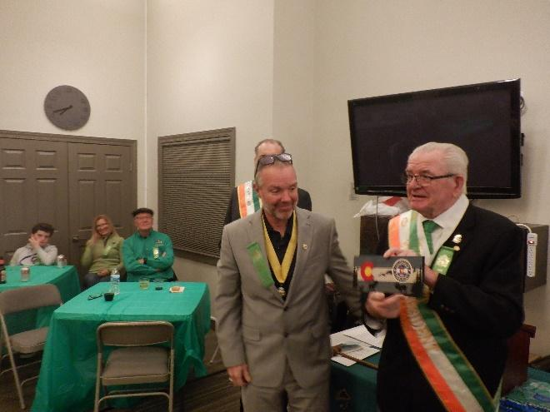

And then we had a couple of reveals:
A new state banner,
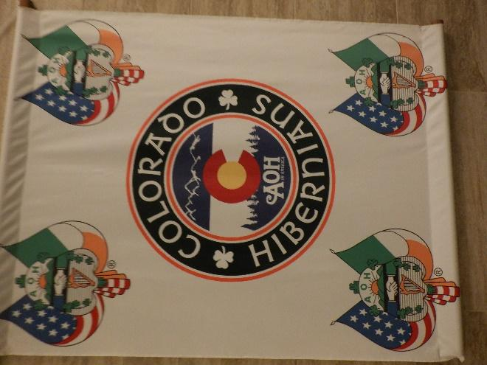

And a new parade banner:
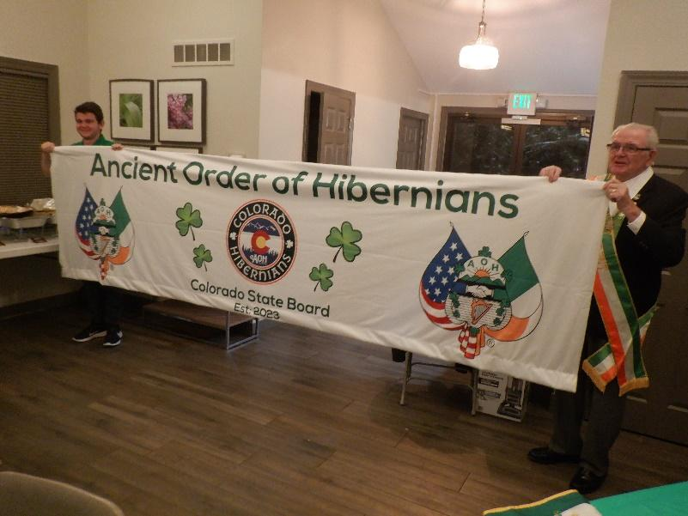
We then enjoyed fellowship with our brothers, families, and members of LAOH with a catered BBQ meal.
Thank You! Thanks You! Thank You!
Many thanks to the officers of the MIchael Collins Division who did a tremendous job in moving us forward this year. Special thanks to our Committee Chairmen. You brought great information to meetings and really helped to promote the work of the order. You made our meetings more interesting by connecting to your counterparts at National. Thank you for all of your hard work. I have often said that the most important thing we do as Hibernians is pray for one another. Thanks to Bill Beach for getting the word out when we had a brother in need of prayer. Deacon Jim is the best Division Chaplain in the country. As our spiritual leader, mentor, friend and brother we are blessed to have you, Deacon. As the oldest active and largest Hibernian Division in the State of Colorado, the Michael Collins Division, has set the standard to follow. We have much to look forward to in the coming year as we continue to grow the AOH in Colorado. I Hope you all have enjoyed the newsletter this year thanks to the editor in chief, Jim O’Shea. I would be remiss if I didn’t mention my partner in crime, John Aylward, who has spent copious hours of hard work to help us accomplish our goals this year. We are in good hands as John takes over as president in 2024.
Merry Christmas to all Brothers and a Happy New Year to you and your families.

HAPPENINGS:
At the Michael Collins Division 1 Denver Membership Meeting Wednesday December 13, 2023. New officers for 2024 were elected:
President – John Aylward
Vice-president – Tim Henning
Financial Secretary – Ted Rhoades
Recording Secretary – Kevin Jones
Standing Committee – Dan Quinlivan
Treasurer – Mike Collins
Marshall – Sean Hudson
Sentinel – Neil Quinlivan

Nollaig na mBan
Ladies Ancient Order of Hibernians’s
Women’s Little Christmas
American Legion Post 1
5400 E Yale Ave., Denver, CO 80222
January 5th, 2024
Michael Collins Division officers installation will take place following dinner. Brothers we have offered to do setup and cleanup before and after the party. Please RSVP ASAP.

Hope to see you all soon.
Tim Henning - President
Jim O’Shea – Newsletter Editor

